Independent Regulators’ Group – Rail

IRG–Rail
Working Group Access

Overview on European Performance Schemes

28 October 2017

Table of Contents

I. Introduction 4
II. Questionnaire on Performance Scheme – main results 6
II.1. General questions 6
II.2. Delays and attribution 8
II.3. Charges 9
II.4. Dispute resolution 10
II.5. Evaluation of the Performance scheme 11
II.6. Control of the Performance scheme 12
III. Short descriptions of the respective Performance Scheme in a member state 13
III.1. European Union 13
III.2. Austria 13
III.3. Belgium 14
III.4. Germany 14
III.5. Hungary 15
III.6. Lithuania 15
III.7. The Netherlands 16
III.8. Norway 17
III.9. Poland 18
III.10. Portugal 18
III.11. Romania 19
III.12. Slovenia 19
III.13. Spain 20
III.14. Switzerland 21
IV. Case Studies 22
IV.1. Case study on the UK performance scheme (Schedule 8) 22
IV.1.1. Introduction 22
IV.1.2. Delays and attribution 23
IV.1.3. Charges 23
IV.1.4. Dispute resolution 24
IV.1.5. Evaluation of the Performance Scheme and Regulatory control 24
IV.2. Case study Sweden 25
IV.2.1. Introduction 25
IV.2.2. Delays and attribution 25
IV.2.3. Charges 25
IV.2.4. Dispute resolution 26
IV.2.5. Evaluation of the Performance Scheme 27
IV.2.6. Regulatory control 27
IV.3. Case study Italy 29

Introduction
- As foreseen in the working programme 2017 of the Working Group Access, IRG-Rail has produced a review on performance schemes in IRG-Rail member states. For this the WG Access started with drafting a questionnaire which was issued to all IRG-Rail members. The answers from 21 countries have been gathered in an overview sheet, the conclusions that could be drawn are presented in the first chapter of this overview paper.
The Working Group Access also held an IRG-Rail internal workshop on performance schemes on 28th March 2017.
- The questions and answers of the questionnaire can be grouped into the following fields of interest: The first section “General questions” addresses main topics such as whether a performance scheme is implemented in the member state, who introduced it, to which type of traffic does it apply and its general format.
- The second section covers the handling of delays and their attribution. The main questions are therefore dealing with e.g. the recording of the delays, the respective recording system, the responsibility for the attribution of delays and delay causes.
- The third section gives more details on “Charges” within the performance scheme. Therefore the penalties, bonuses and compensations as well as the way of calculating them are the core of this chapter. In addition there is a comparison of the absolute financial level, meaning the “value” of a delay minute,. Capping of penalties and the method of compensation payments are further topics.
- The following section “Dispute Resolution” addresses the national dispute resolution systems that are implemented to clarify diverging views on delay attribution. The chapter compares if there is a dispute resolution system and how the procedure of assessing responsibility for delays is designed as well as how is dealt with differing opinions on responsibilities.
- Two key chapters form the last part of the evaluation of the questionnaire. These two chapters deal with the “Evaluation” of the performance schemes and their regulatory “Control”. Based on the answers to the questionnaire, not many performance schemes in place show positive results with regards to a reduction of delay minutes. Nevertheless the reduction of delay minutes is an indicator – but not a sufficient monitoring parameter for the effects of performance schemes. The chapter addresses the applied monitoring parameter and shows who evaluates the performance scheme, if results are made public and to whom.
The chapter “Control” addresses the regulatory influence on the performance scheme. It deals with the role and the influence of the regulatory body on the performance scheme.
- The results of the aforementioned workshop on performance schemes complemented by contributions of the working group members can be found in this paper: A short description of performance schemes is available for the following countries: Austria, Belgium, Germany, Hungary, Lithuania, The Netherlands, Norway, Poland, Portugal, Romania and Spain. Detailed descriptions in the form of case studies have been submitted by Sweden, UK and Italy for their national performance schemes. These contributions should enable a comparative overview of national approaches.
- With this paper IRG-Rail aims at providing a first overview of the functioning of the performance schemes and the similarities and differences between the national systems. The paper shall be updated in due time, if the information base of the questionnaire is updated and new developments or approaches allow new findings.

Questionnaire on Performance Scheme – main results
- 21 regulatory bodies have answered a questionnaire on the performance schemes that their incumbent infrastructure managers (IM) have implemented in their countries. Those regulatory bodies are from: Austria, Belgium, Bulgaria, Croatia, Denmark, Finland, France, Germany, Greece, Hungary, Italy, Lithuania, The Netherlands, Norway, Portugal, Romania, Slovenia, Spain, Sweden and the UK. Switzerland has mentioned that a performance scheme has not been introduced yet.
- The questionnaire was divided into several subtopics. Each subtopic is summarized below, giving an overview of the relevant characteristics in the member states.

II.1. General questions
- Performance schemes according legislation must aim at encouraging railway undertakings and the infrastructure manager to minimize disruption and improve the performance of the railway network.
- The original provision regarding the obligation to have a performance scheme is contained in article 11 of Directive 2001/14/EC (the Recast Directive) as amended by article 35 of Directive 2012/34/EU that specifies more in detail, in annex VI point 2, the principles that member states have to apply for its implementation. Findings show that this annex has been implemented in national law in 14 countries (Austria, Belgium, Bulgaria, Croatia, Denmark, Finland, Hungary, Lithuania, Norway, Portugal, Romania, Slovenia, Spain and the UK), or is referred to in national legislation (e.g. in France and Italy). In Denmark, it has been only partially implemented.
- In 20 countries out of 21, a performance scheme is currently in force. Some IMs have implemented and offered a performance scheme for many years (e.g. UK since 1994/95). In some cases the performance scheme has been introduced only recently. In France, the scheme it is working in an experimental mode, and a performance scheme does not yet exist in Spain. In 12 member states further developments of the system are planned.
- In general it is the IM (or in Slovenia the Allocation Authority and in Hungary the independent capacity allocation body) that has developed the performance scheme, and in the majority of respondent countries (10 cases) this been done in cooperation with (or after consultation of) the railway undertakings (RU). In Belgium law has introduced the performance scheme, even if this country (as well as Germany and Spain) is planning to include RUs in the future improvement process of the regime. For Spain national legislation prescribes the establishment of committees for dispute resolution and for the monitoring of the performance scheme which include RUs and IMs. In the UK the establishment of such committees is exist as prescribed in the access contract (framework agreement).
- Directive 2012/34/EU annex VI 2 (a) establishes that the level of performance to be achieved has to be agreed by IM and the applicants. In general, according to the answers received, such agreement is reached through consultation and periodic meetings that allow the IM to take into account the views of RUs. The German regulatory body (Bundesnetzagentur) considers however that, in order to avoid discrimination, different agreements on performance levels between IM and RU should not be possible. Therefore in Germany any arrangement is to be included into the network statement by the IM and to be consulted with all RUs during the regular consultation of the network statement. In France, a commission including the IM and RUs sets up performance targets annually.
- In addition to the performance scheme required under article 35 of the Recast Directive, in some countries there are other performance related schemes in particular under agreements between RUs and competent authorities (State, Regions) for the provision of public service contracts.
- In all cases the information about the performance scheme is published in the network statements, and in Slovenia additionally also in the Official Gazette ("Decree on Train Path Allocation, Network Time table Construction, Infrastructure Charges and Performance Regime on Public Rail Infrastructure"). In Romania, the performance scheme is part of network access agreement. In the UK a summary is on the IM’s website and in the network statement. Full details are contained in a Schedule to track access contract (i.e. framework agreement). Information on performance schemes is also available on the website of the regulator (ORR). In addition, the policies, procedures and processes for attributing delays are published by the Delay Attribution Board - the rail industry body providing guidance on attribution of train delays in Britain.
- For all respondents that have implemented a performance scheme, the information on delays and reasons of delays are available to each RU concerning their trains. In most countries (10 cases), RUs have also access to information about delays and reasons for delays concerning all traffic on the network. In Italy, each RU has a real-time full view of the overall traffic (including trains of other RUs) on the portion of infrastructure where it operates, while in Sweden this is the case for all lines.
- In the UK and in Germany only the mainline IM has all details of delay incident causes and responsibilities. Passenger and freight RUs have detailed information on their own delays and those owned/caused by other operators that affect their services.
- In most countries the performance scheme as a whole applies in all circumstances (i.e. periods of time or situations). In some countries, however, performance schemes do not apply in cases of extreme weather conditions (as reported by Sweden and Finland), strikes (France) or needs of government agencies - border police, customs, etc. (Romania).
- Performance schemes cover international routes/PaPs in Austria, Belgium, Bulgaria, Croatia, Finland (only between Finland and Russia, on Finnish side), Germany, Italy, the Netherlands, Norway, Portugal, Romania, Slovenia, Sweden and the UK. Where the performance scheme covers international routes/PaPs, it does not take into account the punctuality of the whole route, but just the national part of the route; in Italy, Germany, Austria and in Romania the delays at the borders are neutral.
- The questionnaire also investigated the specific content of each national performance scheme. It showed that for passenger and freight traffic, delays at destination and at intermediate points are penalized in 10 member states. On the other hand only delays at final destination of the train are penalized in 3 cases (Austria, Bulgaria and Spain) for passenger traffic, and in 4 cases (Austria, Bulgaria, Spain and the UK) for freight traffic. In Portugal the performance scheme currently in force foresees the penalization of delays at departure, destination and possibly delays at intermediate points.
- In all countries there are thresholds/benchmarks for calculation of delay payments: only delays in excess of a preset amount of minutes are penalized. In some countries thresholds for freight traffic are sensibly higher than for passenger traffic. Thresholds in minutes vary between 3 and 240 minutes for long-distance passenger traffic, between 3 and 60 minutes for regional passenger traffic and between 5 and 120 minutes for freight traffic.
- Concerning cancellations, in 8 countries they are included in the performance scheme. In Sweden only cancellations made later than 24 hours before the scheduled departure are considered (in Denmark prior 72 hours). In some countries cancellations are treated as a specific number of “deemed minutes late”: any cancellation is penalized as a delay of a predetermined amount of minutes (Italy: 120 minutes, Belgium: 60 minutes, the UK: depending on the service groups for passenger traffic, Portugal: 30 minutes).

II.2. Delays and attribution
- For the recording of train delays, in 11 out of 19 cases, an automatic system records when the train runs on time. In all the cases the recording system is owned and operated by the IM. Registered data are kept in a database indefinitely in Belgium, Finland, Italy, Norway and the UK. In Sweden the regulatory body has noticed a lack of guarantees from the IM’s side for how long data is being kept. So far, however, the IM has kept data from 2001 and onwards. In other countries the period of data conservation is set, ranging from 3 months (the Netherlands) to 15 years (Denmark).
- In all cases there is a list describing the causes of delay. The list is public or supplied by the IM on request of stakeholders (RUs). Generally, the list is published:
- In network statements or their annexes (Austria, Croatia, Hungary, Germany, Sweden, Romania),
- In technical or operative documents of the IM (available on request in Italy). In the UK the delay attribution guide is on the websites of the Delay Attribution Board and the IM,
- on informative system (IT-system) of the IM (France, Greece),
- in the infrastructure access agreement (Finland, Romania) or
- In legal text (Belgium, Spain, Lithuania).
- In 8 countries the list of causes of delays follows the classification of annex VI 2 (c) of Recast Directive. In other countries there are small differences that are likely to be eliminated in the future, in Germany in the network statements 2018 of DB Netz AG) Italy, and Sweden. In other countries it will be implemented or applied in future (Bulgaria, Portugal and Spain). In the UK the list is already reflected in the main in the delay attribution guide.
- Annex VI 2 (c) contains at points 8 and 9 causes of delays attributable to neither the IM nor the RUs (e.g. strikes, weather and natural causes). In some countries “other” causes of delays are excluded from liability of both the IM and RUs, for example:
- In Austria as detailed in annex VI 2 (c) 4 of the network statements (delays attributable to other IMs), 6.2 (formation of train by RU), 7 (delays attributable to other RUs) and ad hoc traffic;
- In Germany delay causes mentioned in Annex 6 No. 2, (c) 7 of the network statements (delays attributable to other RUs).
- In Italy the annex to the network access agreement lists the paths concerned by maintenance time-slots (PIS paths) and the expected delays which do not generate performance scheme penalties. Concerning the paths affected by interruptions due to maintenance works, not specified in the network access agreement, the performance scheme does not apply to the planned delays notified to the RUs between 30 and 7 days before the date of interruption.
- In 9 cases secondary or follow-up delays (consequential delays) are included in the performance scheme and are attributed to the RUs which caused the disruption and which has suffered financial consequences. Follow-up delays are not recorded in Hungary, Finland, Greece, The Netherlands, Germany and Romania. In Portugal the IM is considering the possibility of introducing secondary delays in the new performance regime to be implemented in the future. Follow-up delays are recorded but not payable in Sweden. The IM has introduced charges for these delays in the network statement 2017, but after a short period of pilots they cancelled the model. The Swedish regulatory body has noticed that charges for consequential delays do not seem to be in the network statements for 2018 or 2019.

II.3. Charges
- According to the Recast Directive article 35 paragraph. 1, performance schemes may include “penalties for actions which disrupt the operation of the network, compensation for undertakings which suffer from disruptions and bonuses that reward better-than-planned performance”.
- It results that in all countries performance schemes include penalties. With regard to compensations and bonuses, the results of the questionnaire are less clear, but it is possible to conclude that compensation systems are less homogeneous.
In particular, some countries (Austria and Germany) interpret “compensations” only as payments for delays caused by an RU to another RU. In countries where the performance scheme includes such compensations, i.e. Bulgaria, Italy, Slovenia, Spain, and the UK, all payments flow through the IM that acts as an intermediary. Other countries include in “compensations” also payments for disruptions caused by the IM to RUs. In the UK and in Romania the regime envisages payments for delays caused by both other operators and the IM. In Portugal the performance scheme also envisages that RUs receive a bonus for the delays caused to their trains by the IM or other RUs.
- The existence of a bonus is indicated by 9 countries over 19.
- The methodology of calculation of penalties varies largely across countries, so it is difficult to deduce general rules. Nevertheless it is possible to identify some main differences in the methodology approach.
- In some countries (Austria, Germany, Slovenia) the level of penalties is proportional to the level of delay minutes, provided that thresholds are exceeded and caps to penalties are applied (see below). In other countries, the level of penalties is differentiated for passenger/freight traffic (Bulgaria, France, Italy, Lithuania, Portugal, Spain, Sweden, and the UK). Additional criteria of differentiation are: scheduled/ad hoc trains (Italy, Romania), commercial/service trains (Italy, Sweden), line type (Italy, Spain), and service groups (i.e. group of train services, operating in a similar geographic area and of a similar type) for passenger operator (UK), etc.
- In some countries penalties are calculated in absolute terms (e.g.: Austria 0,5 €/min, Denmark 700 DKK/delayed train, Hungary 20 HUF/min), in other countries as a percentage of the access charge). In Romania the penalty for one minute of delay is 0.2 leu / minute. The maximum monthly penalty of one of the parties may not exceed 1% of the total AC amount which has to be paid per month of the respective RU.
- In some countries penalties, bonus or compensation depend on a comparison between performance achieved and predetermined performance targets or thresholds/benchmarks (Denmark, France, Germany and UK).
- Only in the UK, the payment rate for passenger traffic reflects the long-run revenue impact of the delay for the passenger operator and for freight the average financial impact to a rail freight operator of each minute of delay. In other countries compensation is not related to costs incurred by RUs.
- With the exception of Bulgaria, Lithuania, Portugal, Sweden and the UK (passenger services), all countries apply a cap to payments of penalties. In several countries the cap applies to individual train penalty payments (Finland, France, Greece, Italy in the scheme actually in force, Slovenia). In other countries, there is a cap for total annual penalty payments due by a single RU that is expressed either in absolute value (Denmark, France, and Germany) or as percentage of annual access charge (Italy and Spain). In the UK, freight operators can benefit from a cap agreed with the IM and approved by the regulator.
- As a result of different criteria and parameters employed, the amount of net payments from the IM to RUs assumes positive values in Finland, Sweden, Bulgaria and UK and negative values in Italy, Germany, and Hungary.

II.4. Dispute resolution
- Annex VI paragraph 2g of the Recast Directive states: “Without prejudice to the existing appeal procedures and to the provisions of Article 56, in the case of disputes relating to the performance scheme, a dispute resolution system shall be made available in order to settle such matters promptly. This dispute resolution system shall be impartial towards the parties involved. If this system is applied, a decision shall be reached within a time limit of 10 working days; (…)”
- On this basis, part of the questionnaire has addressed this topic in order to determine whether there is a well-established procedure for the assessment of delays between RU and IM. In all countries (except for Norway) there are well established procedures for the assessment of delays.
- Some of the dispute resolution systems have deadlines for complaining. Complaints can be brought before committees, addressed in negotiations or at monthly meetings. The regulatory bodies can be involved in case of a dispute.
- A dispute resolution system has been introduced in all countries except for Germany and Greece. The final arbitrator of the dispute resolution system is the regulatory body in Austria and Belgium. In Slovenia and in Lithuania, the final arbitrator was the allocation authority, but, following the transfer of essential functions from the allocation authority to the IM in 2016, a dispute settlement body of representatives of the IM and RUs was established. In Croatia, France, Spain, Denmark, Italy, The Netherlands, Norway and the UK committees act as final arbitrators. The committees are composed differently. They can include representatives of the IM and RUs or other institutions. In Bulgaria, Sweden and Romania the final arbitration is done by the courts, but the regulator decides in the case of preceding disputes. The IM is the arbitrator and has final decision powers in Germany. In Austria, Belgium, Finland and Slovenia the regulatory body decides in the case of disputes. In Croatia, France and Spain as well as in The Netherlands and the UK it is the previously mentioned committee.
- Rules for the attribution of delays can mostly be found in the network statements of the IMs. No attributions rules are available in Denmark, Finland, Hungary and Romania. For Italy they are described in an operational communication. In the UK they are described in the Delay Attribution Guide.

II.5. Evaluation of the Performance scheme
- Only a few countries report that positive performance results can be attributed to their performance schemes. These are Bulgaria, Croatia, Denmark, Italy and Portugal. Minimal effects or no clear results can be found in Austria, Finland, Belgium, France, Germany, Slovenia and the UK. In Greece, Hungary, Lithuania, The Netherlands, Norway, Romania and Sweden there are no results available. In the UK, although performance improvements have been observed, there is no clear and objective evidence that they are driven by the performance scheme.
- The amounts of delay minutes that have been allocated to the IM and to the RUs are available in all countries except for Greece, Hungary, The Netherlands, Norway and Slovenia (in Slovenia the results are made public for the involved stakeholders, but are not published). The levels of payments that are generated by the performance schemes differ largely in the countries observed; a separate and detailed evaluation would be needed. The results of the performance schemes (referring to total delay minutes and resulting payments) are published in Austria, Denmark, France, Romania, Sweden and the UK (in UK both cancellations and performance measures are published).
- The answers to the questionnaire show that there is no common approach for the evaluation of the performance schemes. The performance schemes are evaluated by different stakeholders. In some countries they are evaluated by independent bodies: in Belgium it is evaluated by the government, in Slovenia and Hungary by the allocation body, in Bulgaria, Germany, Greece, Portugal, Romania, Sweden and the UK by the regulatory body. In the UK the delay attribution board reviews the Delay Attribution Guide; in Denmark and Finland this is done together by the IMs and RUs.
- Monitoring parameters can cover different measures such as the overall punctuality, the effectiveness (referring to a change in behavior of affected parties and though in a reduction of delays), the overall economic flows generated by the performance scheme and data quality. Those parameters are all considered in Bulgaria, Denmark, Sweden and the UK. A couple of those parameters are used in France, Romania and Slovenia.
- Key performance indicators are used in Denmark, Hungary, the Netherlands, Romania, and Slovenia. The mostly used indicator is the punctuality. In the UK, performance is monitored based on public performance and cancellation measures. Sweden is in the process of defining key performance indicators.
- Regarding the evaluation of the performance scheme only a couple of countries have a consultation with the RUs and applicants. Consultation takes place in Denmark, Greece, Slovenia and the UK. In case that the performance scheme is evaluated, a consultation is made in The Netherlands. In Romania and Sweden the RUs are consulted, but informally.

II.6. Control of the Performance scheme
- The framework for approval of the performance scheme varies significantly across the IRG-Rail member countries. The ministry approves the performance scheme in Belgium and Denmark. It is ex ante approved by the regulatory bodies in Austria, Bulgaria, France, Germany, Italy, Portugal and the UK. The approval is done by the IM in Croatia and by the IM and RUs in Finland, the Netherlands, Romania, Slovenia, Spain and Sweden. No approval is necessary in Greece, Hungary and Norway.
- The ex post monitoring is done by the regulator in Austria, Belgium, Bulgaria, Croatia, Finland, France, Germany, Italy, Norway, Portugal, Slovenia, Sweden and the UK. There is no ex post monitoring by the regulatory body in Denmark, Greece, Hungary, Lithuania, the Netherlands and Romania. The system is monitored by the IM in Denmark, The Netherlands, Romania and Spain.
- Being asked, if the performance scheme applied is suitable for achieving the goals determined in the Directive, only Bulgaria, Denmark, and Greece answer positively. In some countries no evaluation is yet possible.
- In three countries there have been complaints about the performance scheme. These are Bulgaria, Denmark and Germany. Legal proceedings have been initiated in Belgium (advice issued by the regulatory body), Bulgaria, Italy, Germany and Sweden. In the UK the performance scheme is reviewed and consulted on as part of the periodic review.

Short descriptions of domestic Performance Schemes
- During the workshop organized by the Working Group Access participants had the opportunity to present their national performance scheme in brief. Following the workshop members of the working group were asked to provide short descriptions of their national performance schemes to integrate them into the present paper. The following details should allow further comparisons of national performance schemes. They complement the findings of the questionnaire forming the first part of this paper.
- This section also contains a short description of the former European performance scheme that was developed a few years ago. Information is taken from the Rail Net Europe (RNE) website and from the EPR handbook 2013.

III.1. European Union
- The European Performance Regime (EPR) is a system of quality monitoring in terms of punctuality and delay causes, which supports performance improvement in international train traffic and foresees the possible application of financial penalties to bad performance.
- Data - originally collected from national monitoring systems and combined into international train run information in the TIS-system (Train Information System) – is checked for completeness and correctness. Delay causes are validated by the responsible partners. A calculation procedure measures the performance and the effects of delays on other parties involved in a train run.
- Finally, it enables the users to introduce an incentive system, in which poor performance is penalized and good service rewarded. It is important to highlight that the system aims to enhance performance, not to compensate damage.
- The EPR consists of the following steps:
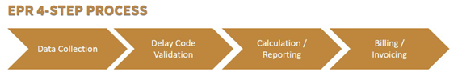
- Stakeholders have indicated that it is not a priority and it is unlikely that it will be applied in the short and medium term.

III.2. Austria
- The Performance Scheme in Austria was introduced by law in 2006. The IM implemented it in 2010 (passenger) and 2011 (freight). Today it covers freight and passenger trains in the regular timetable but no ad hoc trains. Trains that have been deviated are treated as ad hoc trains. The delay is monitored at the final destination of the train. The threshold is set at 10 minutes for passenger and at 60 minutes for freight. The causes for the delays are encoded by the dispatcher in accordance with the UIC 450-2 codes. Disputes can be solved bilaterally between RU and IM with the possibility of making a complaint to the regulatory body. The delay reasons are grouped as follows: IM, RU and neutral. Details are published in the network statement. Late handover at a border crossing is considered neutral. Only the delay minutes caused by the IM or RU are counted. Every delay minute is assigned to one of the 3 groups and summarised. There is a cap of 120 delay minutes for calculating the penalty. The penalty is set at 0.5628 Euro/Minute. There penalty may not exceed 0.5 percent of the infrastructure usage fee for the minimum access package. In 2016 RU penalties reached 482 000 Euro whilst IM penalties totaled 215 000 Euro.

III.3. Belgium
- The old performance scheme (PS) was laid down in law until 31/12/2016. Legislation foresaw that the IM had to determine a new PS in agreement with the applicants (as foreseen by annex VI of the Recast) in time to start at 1/1/2017.
- In the light of this requirement, the IM proposed a new scheme, which was very similar to the old one. There were only two significant changes: 4 instead of 3 segments and the lowering of the volume of the performance scheme from 12 million to 6 million (closed system).
- The regulatory body had already expressed concern regarding the old PS, considering that it was not in line with legislation and not efficient. Since the new proposed PS was almost identical to the old one, the same issues remained. The regulatory body mentioned this to the IM on several occasions and also formally via an official notice. In September 2016 the IM informed the regulatory body that they had not managed to get an agreement with the RUs. In search of a solution Infrabel (the IM) turned to the Minister of Mobility that granted them an extra 6 months to come up with a new PS, which had to be in line with legislation and had to take into account the remarks formulated by the regulatory body in his advice. As a result, to date there is still no PS in Belgium. The regulatory body has started an ex-officio investigation to look into the steps taken by the IM to fulfil its legal duties.

III.4. Germany
- According to paragraph 39 of the German rail regulation law (ERegG), the IM is obliged to establish a charging system which includes performance-related components for the railway undertakings and infrastructure managers to reduce disturbances themselves and to increase the performance of the rail network. This performance scheme should cover the entire railway network of the infrastructure manager.
- At the beginning of 2016 a joint working group comprising representatives from RUs, DB Netz AG (the IM) and Bundesnetzagentur (the German rail regulatory body), discussed the planning and the development of an effective Performance Scheme in Germany.
- DB Netz AG notified Bundesnetzagentur of an amendment to the network statement at the end of 2016 concerning the introduction of a new performance scheme. However, in February 2017 the ruling chamber of the Bundesnetzagentur objected to the proposed performance scheme. An effective performance scheme in Germany will probably not be operational before the end of 2017. In March 2017 DB Netz AG took legal action against the ruling chamber’s decision. The joint working group is still continuing its work to model a performance scheme, independently of the lawsuit.

III.5. Hungary
- The scope of the Performance Regime covers:
- railway company operating nationwide open access, not for own railway network (hereinafter referred to as infrastructure manager),
- railway undertaking (RU),
- non-RU applicant
- rail regulatory body,
- Rail Capacity Allocation Body
- The territorial scope of the performance regime covers the whole open access railway networks in Hungary. Provisions of the Performance Regime apply equally and non-discriminatorily both to the applicants and to infrastructure managers. The general requirements of the Performance Regime are simplicity, transparency, liability, cost-efficiency, usage of measurable data. In addition, it must not impose excessive legal and/or administrative burden either on applicants or on infrastructure managers.
- The Performance Regime includes:
- incentive scheme to facilitate punctual train run
- incentive schemes supporting environmentally friendly transportation
- other incentive schemes related to train run.
- Performance Regime must always be established aim-oriented. Checking the achievement of the objectives that were previously defined is an essential part of the functioning of the system. Regarding measures to be taken within the framework of the Performance Regime such measurable objectives must be set, the realisation of which would have an effect as it is anticipated. As a result, expectations towards the Performance Regime must be determined accurately and in a transparent way so as to give information to the market players on the probable positive effects of the Regime.
- The Performance Regime must motivate the schedulable and optimal use of railway services. Flexibility is an important factor in railway transportation because of the competition with road transportation.
- The Performance Regime is part of the ‘General Terms and Conditions for the Use of Railway Infrastructure’ of the contractual connection concluded between the infrastructure manager and the applicants.

III.6. Lithuania
- In the Lithuanian Railway Code (thereafter – Code) Art. 25¹ provides that Rules for setting penalties and compensations are set by the Government or an accredited institution; the Decision regarding performance schemes is set in the Decision of the Ministry of Transport (2012-01-24) No. 3-53 „Description of Identification and Appointment Procedure for Penalties for Traffic Disturbances and Compensation for Such Disturbances to the Affected Undertakings“.
- Information about train delays must be collected/calculated by the infrastructure manager and should be based on the cause of train delays and the entity which is responsible for the disruption of traffic:
  - the actions or omissions of the public railway infrastructure manager (thereinafter – IM) in the planning or performance of the movement of trains;
  - breakdowns in the items of the public railway infrastructure (thereinafter – Infrastructure);
  - execution of construction or repair of the Infrastructure; actions or omissions of undertakings whose trains were delayed or canceled;
  - rolling stock failures and train formation of undertakings whose trains were delayed;
  - the actions or omissions of undertakings, other than undertakings which trains have been delayed (e.g. undertakings, which trains used infrastructure before or after the undertakings, which has had delay);
  - external causes beyond the control of the IM or of undertakings; secondary causes beyond the control of the IM or of undertakings.
Delays or cancellations fall under the responsibility of a particular single entity with regard to traffic disruption and the ability to re-establish normal traffic conditions according to objective circumstances, if it is feasible to do so.
- Penalties for train delays:
- for a delay of one local passenger train exceeding 30 minutes – 110 Euro;
- for a delay of one international passenger train exceeding 30 minutes – 194 Euro;
- for a delay of one freight train exceeding one hour – 64 Euro;
- for one canceled train – the advance payment for the minimum access package;
- for one single kilometer of canceled local passenger train route – 1,7 Euro;
- for one canceled international passenger train – 2520 Euro;
- for one canceled international passenger train – 753 Euro;
- for one single kilometer of canceled freight train route – 1,7 Euro; The IM is released from a penalty if information is available more than three days in advance.
- The decision whether to impose or not a penalty for delayed and canceled trains, as well as on the amount of the penalty (hereinafter – decision) must be approved by the formed commission of the IM (hereinafter – the commission). The commission must inform not only the undertaking – subject to a fine – about the decision, but also the undertaking that has been affected by the delay (e.g. recipient of the penalty) within 10 working days after the reporting day. The decision to impose a penalty on the undertaking is taken if the delay or the cancelation has been caused by this undertaking. The decision to impose a penalty on the IM must be taken if the undertaking has delayed or canceled its trains due to the IM fault.
- Undertakings that disagree with the decision may appeal (not required by prior non-judicial procedure) to the State Railway Inspectorate under the Ministry of Transport and Communications (hereinafter – the Inspection). The Inspection must take a decision within 10 working days. Every year, at the latest by 1 March of each calendar year, the IM must publish on its website the annual report for the period of validity of the service timetable, indicating how many trains have been delayed, how many cancellations have been made and for what individual reasons and how many trains arrived on time.

III.7. The Netherlands
- The purpose of the performance scheme offered by ProRail in the network statement is to minimize disruptions to train traffic and to promote the availability of the infrastructure, while improving the performance of the railway network and the system as a whole. The performance scheme therefore stimulates railway undertakings as well as ProRail to achieve prompt performance of the train service in accordance with the agreed capacity. The scheme has been specified for the passenger transport market segments and the freight transport market segment.
- ProRail reports on the realized performances, as well as the resulting penalties or discounts, in the manner as detailed in the various parts of the scheme. Additionally, ProRail reports annually to the relevant railway undertakings on the average performance level per market segment. The choices regarding the operational parts of the performance scheme are laid down in the Access Agreement.

III.8. Norway
- In accordance with the recent railway reform in Norway and the transposition of the Recast directive into Norwegian national law, a performance scheme was introduced in 2017. The performance scheme aims to encourage both infrastructure managers (IM) and railway undertakings (RU) to prevent operational disturbances. The performance scheme is based on the principle that between the IM (Bane NOR) and the RUs operating traffic (passenger transport or freight transport) on this infrastructure there is a mutual obligation to deliver or utilize allocated routes without causing delays / cancellations.
- In the case of a breach of this obligation by one of the parties, the party that causes the delay / cancellation must pay compensation within certain limits. In the case of delays / cancellations caused by the IM, compensation is granted to the RU affected by the delay / cancellation. In the case of delay / cancellation caused by a RU, compensation is paid to the IM. . Cancelled freight trains are not compensated by the IM under the current performance scheme, because there is another temporary compensation scheme for cancellation of freight trains in Norway.
- The main feature of the performance scheme is that negative deviations from predefined requirements/targets trigger entitlement to compensation or extra charges for RUs. A freight train is regarded as punctual when it arrives to the end destination within a margin of 5:59 minutes deviation from the timetable. Delays are also measured at several fixed points along the line.
- A passenger train is regarded as punctual when it arrives at the end destination within a margin of 3:59 minutes deviation from the timetable. Deviations related to force majeure are not considered as a delay/cancellation.
- Under the current performance scheme, the starting point for calculating deviation is not zero delays and zero cancellations. For each RU there is a benchmark for an expected level of performance, for instance 98 percent performance, and deviations beyond this will generate payments. In the proposed amended performance scheme the starting point for calculation will be zero delays/cancellations, i.e. all registered delays above the thresholds of 3.59 and 5.59 minutes will generate payments/increase/decrease of charges.
- The performance scheme is connected to the track access charges, and compensation from the IM to a RU is equal to lower charges and vice versa. The track access charges in Norway are however rather low, and this is reflected in the impact of the performance scheme.
- General track access charges were introduced in Norway from 2017 and the charges are NOK 0,625 (EUR 0,0676) per actual driven train kilometer. In addition, there is a capacity charge of NOK 675 (EUR 72) per train departure during rush-hour in four cities (Oslo, Bergen, Trondheim and Stavanger).
- For freight trains there is an additional temporary compensation scheme compensating for the lack of quality of the infrastructure. This scheme was established with effect from March 2016, and is planned to be active for three years until the infrastructure is upgraded to an appropriate level. Compensation according to this scheme is given by the IM to the RU if a scheduled freight train has to be cancelled because of deficient infrastructure:
- A fixed amount of NOK 50,000 (EUR 5370), - per cancelled train and
- A variable part of NOK 1,000 (EUR 107), - per. Container / wagon
- In June 2017 the Norwegian IM, Bane NOR, proposed amendments to the performance scheme, and a draft was sent to stakeholders for consultation. According to the draft, the temporary compensation scheme for cancelled freight trains will end after March 2019, and cancellation of freight trains will then be a part of the general performance scheme. It is also planned to create a “star model” like in the UK where a third party RU, affected by disturbance from another RU, will be compensated by the responsible RUs. In addition, the new model plans to increase all payments from all RUs responsible for disturbances to create funding for compensation to other RUs for disturbances. In this model there will be no direct link between the scope of the actual damage a RU causes to other RUs and the payments.

III.9. Poland
- The PLK, Polish IM has applied a performance regime on an optional basis since 2012 and mandatory since 2013. It has been applied as a part of railway infrastructure access contracts. The current regime is defined in the Polish Railways Act and was implemented by the IM in 2017 - art. 6.4 and 6.5 of the Network Statement 2017/2018.
- Since 2016 the performance scheme has constituted a part of the Network Statement and is obligatory starting from 2017/2018 timetable. It should be included in the network statement. The level of performance is agreed based on RUs remarks and comments to the PLK’s proposal.
- Delays are attributed according to the SEPE system. RUs involved accept it (indicating “accept” in SEPE) or dispute it (indicating ”claim” in SEPE). The IM is obliged to decide on the claim within 72 hours. If the RU is not satisfied with the PLK's answer, it may appeal till the 15th day of the next month. The RU may also ask the IM to send a copy of all documentation related to the case.
- Penalties are set at PLN 6 (some EUR 1.40) for 1 min. delay beyond 5 min (passenger) or 15 min. (freight) delay paid for delaying another RU train, and PLN 0,5 (some EUR 0,12) for 1 min delay beyond the same thresholds paid to the IM by a RU for causing the delay of its own train. All penalty/compensation payments are coordinated by and done through the IM. There is a train delay catalogue in the Minister's regulation on capacity allocation - it is more or less the same as in annex VI to the Directive 2012/34/EU.

III.10. Portugal
- The performance scheme currently in use in Portugal has been implemented by the IM in 2010 in accordance with a regulation issued by the former regulatory body under the previous legal framework. The scheme implied the conclusion of contracts between the IM and the RUs. The recording of delays is based on an automatic monitoring system (nevertheless allocation of responsibilities for the delays is made manually). The scheme comprises a system of bonus and malus (penalties). Different thresholds for determining delays as well as a different level of penalties in respect of different segments of service are foreseen. A performance “premium” based on the overall performance may be awarded. The regulation issued by the former regulatory body (Regulation 473/2010) was to be revised within a 3-year period and RUs claim that it has expired. As such, although the monitoring and the calculation of delays are still active, the penalties are no longer applied and therefore no financial payments are being made. A new performance regime is currently being developed by the IM to meet the requirements established in Decree-law 217/2015, which transposed Directive 2012/34/EU. The new performance scheme is expected to be approved in 2017 and to be implemented next year.

III.11. Romania
- According to the article 35 of the national law 202/2016, the IM has to establish a charging performance system in order to minimise disruption on the whole network. This scheme may include penalties for actions which disrupt the operation of the network, compensation for undertakings which suffer from disruption and bonuses that reward better-than-planned performance
- Currently, the performance scheme is part of the network access contract between the IM and the RUs and reflects general rules. However, the new modified performance scheme, based on the requirements established in the national law is expected to be developed in 2017 and implemented in 2018.

III.12. Slovenia
- The Performance Regime in the Republic of Slovenia was introduced in 2015 by the Allocation Authority (Public Agency for Railway Transport), which adopted an Act on the method for ensuring the effectiveness of the rail network. Before actual payments of penalties, which started in September 2015, a trial version of calculations of delays was conducted for a period of 6 months.
- In 2016, all essential functions were transferred from the Allocation Authority to the IM by amendment of the Railway Transport Act (implementation of Directive 2012/34/EU), but the performance scheme remained the same.
- The performance scheme is applied in accordance with Article 15f of the Railway Transport Act (ZZelP-UPB8) and Article 43 of the "Decree on Train Path Allocation, Network Time table Construction, Infrastructure Charges and Performance Regime on Public Rail Infrastructure". The methodology is published in Network Statement.
- The performance regime is equally and non-discriminatorily applied to all RUs and IM, based on a contractual agreement between IM and RUs.
- The basic component of the performance regime is train punctuality according to its allocated path; expressed by delay.
- Train punctuality is established at the agreed measuring points of the train run on the basis of the deviation between the scheduled and actual time. The agreed measuring points of the train run are the transport points (points of exchange of the movement of trains, intermediate and final stations) which are defined as points of the train run.
- Causes of delay (primary, secondary and external) are coded in accordance with UIC Leaflet 450-2
  - The delay fee is charged only for primary delay causes, originated on Slovenian network
  - Each primary cause is attributed either to IM or to RU
  - Secondary causes are describing consequences of the primary delay
  - External causes – not influenced by IM or RUs (exceptional weather conditions, fatalities, government actions…)
- Delay calculation considers delay at the destination point or at the interchange point, taking into account tolerance:
  - 10 minutes for passenger trains
  - 60 minutes for freight trains
  - Delay charge is not applied:
    - to the IM for train paths for maintenance of infrastructure
    - to RUs in case of allocated ad-hoc locomotive train path
- Delay charge is calculated by formula:
  - in case of delay, caused by IM: D=t(IM)*C
  - in case of delay, caused by RU: D=t(RU)*C
  - C (compensation cost per minute of delay) = 0,10 €
  - Total amount of charged minutes shall not exceed 300 min. for an individual train.
- Early train operation is not taken into account in the performance regime.
- Dealing with delay causes:
- The IM detects causes and enters information on all primary delays in the IT system (except delays caused by RU).
- In addition the IM enters information on all secondary and external causes of delays.
- If the delay is caused by an RU, the IM attributes a code and sends the information on the delay to the RU for further proceedings.
- The RU either accepts such a delay / or rejects it (and proposes a new code with the relevant argumentation) within 6 hours. If the IM accepts the RU‘s argumentation, he updates the delay code, and the procedure is completed.
- If the RU does not validate delay or fails to reject the delay within 6 hours, the delay is automatically attributed to the RU.
- If the IM and RU cannot agree on the responsibility for the delay, such a delay becomes a subject of dispute resolution.
- For dispute resolution, the IM and RUs have established a dispute settlement body which meets once a month to solve „open cases“.
- If one of the parties does not agree with the decision of the dispute settlement body, it may appeal to the regulatory body.

III.13. Spain
- In Spain there is a framework in order to establish the performance regime (Law 38/2015 and Order FOM/189/2015), but the introduction and the development of such a scheme has not started yet.
- It is foreseen to introduce first the performance regime for high speed services but it requires ADIF and RENFE to previously agree on the main parameters of the incentive system.

III.14. Switzerland
- Switzerland has under Article 9b and Article 21 of the track access ordinance (NZV) the necessary legal basis to introduce performance schemes. But this has not been applied yet.
- The IMs have built their own incentive systems, which work quite well, especially also within the yearly negotiated bonus system (with employees).
- The currently achieved punctuality rates show that there is no need for further action.

Case Studies
- Concerning the most elaborate performance schemes, some selected regulatory bodies gave a broader overview on their schemes at the workshop of the Working Group Access in March 2017. These countries are the UK, Italy and Sweden. Their performance schemes, in the form of case studies, are described below.

IV.1. Case study on the UK performance scheme (Schedule 8)

IV.1.1. Introduction
- In the UK there are separate performance schemes for passenger, freight and charter services. They are commonly referred to as ‘Schedule 8’ after the eponymous schedule of the track access contracts.
- There are regimes for both the Infrastructure Manager and operators. The regime consists of a payment rate and a benchmark – if a party causes more delay than its benchmark, it pays money to the affected operators, if it causes less delay than its benchmark, it receives money. A crude representation of how the amounts paid are calculated is as follows:
$$Amount paid=\left(Actual performance-Benchmark\right)*Payment rate$$
- The case study that follows only considers the passenger operator regime.In the passenger Schedule 8 performance regime ‘actual performance’ and the benchmark are measured in terms of average minutes lateness (AML) over a four week period. AML is, crudely, the difference between the timetabled arrival time at particular stations, known as monitoring points, and the actual time a train arrives at those stations, weighted by passenger numbers.
- To keep the example below relatively simple we will only consider the total lateness to one service running and will only measure lateness at the final destination. A passenger train operator is running a service between stations A and C, stopping at station B on the way.
- The train leaves station A on time.
- En-route between station A and B a signal breaks, delaying the train by 10 minutes.
- The train arrives at station B 10 minutes late.
- The train leaves station B 10 minutes late.
- Between stations B and C the train brakes down and is delayed a further 10 minutes.
- The train is able to make up sometime and arrives at station C 10 minutes late.
- The IM’s benchmark is 3 minutes of lateness and the train operator’s benchmark is 5 minutes of lateness.
- Only station C is a monitoring point, as there is only one monitoring point in this scenario station C has a monitoring point weighting (MPW) of 1.

IV.1.2. Delays and attribution
- The share of responsibility for lateness would be attributed between the IM and the train operator using the TRUST delay attribution system. The system identifies the causes of delay between monitoring points to services and allocates total lateness at monitoring points between the IM and operators based on the proportion of delay each party causes. In this scenario:
- Train delayed 10 minutes between stations A and B due to broken signal and arrives 10 minutes late to station B
  - TRUST would allocate this delay to the IM as it is a fault with a piece of infrastructure on the network.
- Train delayed 10 minutes between stations B and C due to broken down train and arrives 10 minutes late to station C
  - TRUST would allocate this delay the operator as it is a fault with the operator’s train.
- Total delay and lateness
  - 20 minutes of delay for this service (10 minutes caused by the IM for broken signal and 10 minutes caused by operator for the broken down train).
  - 10 minutes of lateness as it arrived at station C 10 minutes late.
  - 5 minutes of the lateness would be allocated to the IM and 5 minutes to the operator as each was responsible for 50% of the delay to the service.

IV.1.3. Charges
- The amount the IM and the operator would pay for the lateness allocated to them in this scenario would be a function of their payment rate and how their performance compares to their benchmark. In practice the IM and the operator’s performance would actually be measured over a four week period to determine if they have performed better or worse than their benchmark.
- The IM would pay the operator for the 2 minutes of lateness that they caused in excess of their benchmark (which we assumed was 3 minutes). So the total amount the IM would pay would be 2 times the payment rate for this particular service group. As this is the passenger operator regime the payment rate would be based on the marginal revenue effect (MRE) of poor performance to reflect the long run revenue losses to the operator. The MRE is the forecast loss of fare revenue to a passenger train operator resulting from one minute of lateness per passenger journey.
- In this example the lateness allocated to the operator, 5 minutes, is equal to its benchmark, therefore the operator would not make or receive any bonus payments with respect to delay they cause (although they might make or receive payments with respect to the delay they experience). The operator payment rates are also set at the service group level and reflect the average financial impact on third parties of each minute of lateness that each operator causes itself.
- In a scenario where an operator did exceed its benchmark the payments it makes to the affected operators would be administered via the mainline IM through the ‘Star Model’ – the IM effectively acts as a central counterparty; all Schedule 8 performance regime payments relating to operator-on-operator delay are made via the IM.

IV.1.4. Dispute resolution
- Due to the nature of the incidents described in this example it is unlikely the IM or the operator would dispute attribution of responsibility for the delays. The Delay Attribution Guide (DAG) sets out the procedures for assessing who is responsible for different incidents.
- In cases where either the IM or an operator did not agree with how delay had been attributed for an incident they do have the option to dispute it. If agreement is not reached the Delay Attribution Board (DAB) will arbitrate, if the decision by the DAB is not accepted it can then be put in front of the Access Disputes Committee (ADC). This is an impartial process, DAB consists of members from the IM and passenger and freight operators and ADC is an independent body.

IV.1.5. Evaluation of the Performance Scheme and Regulatory control
- As part of the periodic review ORR reviews Schedule 8 performance regime to consider if any improvements can be made to the regime to help it fulfil its purposes of:
- Incentivising the IM to reduce the delay they cause
- Incentivising operators to reduce the delay they cause to other operators
- Reduce operators’ exposure to losses that arise from delay and cancellations caused by the IM or other operators
- Industry is consulted on any policy changes we make to Schedule 8 performance regime.
- In addition, Schedule 8 performance regime is re-calibrated at each control period meaning the benchmarks and payment rates and other aspects of the regime, such as MPWs, are updated to reflect the most recent available data. In PR18 this process will be led by industry and overseen and approved by ORR. In the passenger regime re-calibrations for individual service groups can occur in the middle of a control period, for instance an operator may make changes to the stations they stop that require the MPWs to be re-calibrated.
- In terms of delay attribution the DAB continuously monitors the DAG and makes amendments. These are usually due to requests from members (which must be ratified by the industry and ORR) or following a dispute. The DAG is updated twice a year.
- Overall ORR is not involved in the day to day running of the performance scheme but as described above it does set the policies for the regime and has an approval role in relation to the re-calibration process and changes to the DAG.

IV.2. Case study Sweden

IV.2.1. Introduction
- The main Swedish infrastructure manager, Trafikverket, has used a performance scheme since the 2012 timetable. According to the scheme the IM and the RUs are liable to pay penalties for three types of delays:
- Delays between two consecutive monitoring points (paid per additional minute of delay above a 5 minute threshold)
- Major delays (paid only by the IM as a lump sum compensation for delays which exceed 60 minutes for passenger trains and 180 minutes for freight trains).
- Late cancellation of trains (less than 24 hours before departure).
- The opinion of the regulatory body, Transportstyrelsen, expressed in an injunction from 2016, is that the system so far has failed to focus attention on desired effects rather than on monetary flows. There is no evidence that the performance scheme has led to improved performance.

IV.2.2. Delays and attribution
- The IM automatically registers all deviations from the timetable at a large number of monitoring points in the railway network. For each delay exceeding 3 minutes between two points, signallers/dispatchers at the train operating centre attribute a delay code from a list of causes. Each delay code attributes responsibility for the delay to either the IM, the RU, or to no one.

Delay code | Responsible party
Infrastructure | IM
Operational management | IM
Railway undertaking | RU
RU - late departure from depot | RU
Secondary delays | No one
Disturbed by other train | RU
Accidents and external circumstances | No one
Unreported | IM

IV.2.3. Charges
- For delays between two monitoring points, the responsible party pays a charge for each minute exceeding the five minute threshold. There is no penalty for delays which do not exceed five minutes between two monitoring point. As a consequence, a train can accumulate a total delay without generating a penalty under the performance scheme, as long as each delay between two monitoring points is below five minutes.
- For major delays, the IM makes a lump-sum payment to the affected RU. For late cancellations the penalty consists of lump sum payment plus half the train path charge (one component of the track access charge). The charges have increased gradually since their introduction in 2012:

 | 2012 | 2013 | 2014 | 2015 | 2016 | 2017 | 2018
Double-direction IM RU
Infra, operation, unreported | 1.0 | 1.5 | 2.5 | 5.0 | 7.5 | 7.5 | 7.5
RU | 1.0 | 1.5 | 2.5 | 5.0 | 6.5 | 6.5 | 6.5
- Late departure from depot | 0.2 | 0.4 | 1.2 | 1.5 | 2.5/0 | 0 | 0
Disturbed by other train |  |  |  |  |  | 6.5/0 | 0
Major delays IM ► RU
Passenger traffic > 60 min | 600 | 700 | 700 | 1100 | 1375 | 1375 | 1375
Freight traffic > 180 min | 500 | 500 | 500 | 810 | 1085 | 1085 | 1085
Acutely cancelled trains
€ 50 + 50% train path fee* |  |  |  | Y/0 | Y | Y | Y

- The turnover of the performance scheme has increased considerably since its introduction – from €3 million in 2012 to € 21,3 million in 2016. Measured as a share of track access charges, the turnover of the performance scheme has increased from 7,3 % in 2014 to 13,1 % in 2016. In every year there has been a net payment from the IM to the RUs.

IV.2.4. Dispute resolution
- The method for calculating charges is described in detail in the network statement. The RUs have access to the information systems which report delays. If they disagree with the IM’s attribution of delay code they can send a written request for renewed assessment to Trafikverket. Such a request must contain all necessary information and must reach the IM no later than the sixth calendar day after the date on which the train path started. Trafikverket must communicate its final decision no later than the ninth calendar day after the date on which the train path began. From that point the delay code is fixed and serves as the basis for billing and evaluation.
- If a RU believes that the IM has made an error in the attribution of a cause for delay, the RU can raise a complaint to the regulatory body Transportstyrelsen. Transportstyrelsen received the first complaint concerning the performance scheme in June 2017. A freight operator claimed that Trafikverket were wrong in using a delay code for accidents (which does not lead to penalties) rather than the code for infrastructure that would make the IM liable for payment. The regulatory body has not yet come to a decision

IV.2.5. Evaluation of the Performance Scheme
- Trafikverket publishes the total monetary flows and various statistics concerning delay minutes and coding. However, there is no evaluation of the performance scheme in terms of minimization of disturbances or improved performance. The absence of targets, evaluation and long-term planning was a major criticism of Transportstyrelsen’s injunction from 2016 (see below).
- The performance scheme is subject to the same far-reaching consultation with other actors in the railway market as other components of the network statement. So far, the RUs and their associations have as a rule accepted the provisions of the performance scheme.
- The scheme has evolved gradually since its introduction in 2012, with improvements of the delay codes in cooperation with the applicants, gradually increased charges, the inclusion of service trains, and new elements such as the charges for major delays and penalties for late cancellations.

IV.2.6. Regulatory control
- There is no ex ante involvement of the regulatory body in Swedish performance schemes, but the regulatory body has the mandate to conduct ex officio investigations. On request of the Swedish government, Transportstyrelsen published a strategy for regulatory supervision of Trafikverket’s performance scheme in 2014. According to this strategy, Transportstyrelsen will first examine the principles of the performance scheme including delay coding, exceptions, and the treatment of the performance scheme in the network statement and the track access agreements. In a second and third step, Transportstyrelsen plans to examine the level and differentiation of the charges and the precautionary measures taken by RUs and IMs as a result of the performance scheme.
- Transportstyrelsen completed the first phase of the investigation in 2016 and identified a number of weak spots. In particular, the performance scheme fails to link the delay codes and charges to the disturbances it is supposed to prevent. There are no targets and no development plan for the performance scheme and no systematic monitoring and analysis in terms of delays. Transportstyrelsen also pointed to shortcomings in the handling of data for evaluation and invoicing. Transportstyrelsen issued an injunction towards Trafikverket in February 2016 and is still in the process of evaluating Trafikverket’s response.
- In summary, Transportstyrelsen’s view is that even though Trafikverket has developed and refined a performance scheme in consultation with the RUs, the scheme has not been designed in line with the basic idea behind the performance scheme: to minimise disruption, promote proactive behaviour, and improve the performance of the railway network. Rather than being a goal-oriented and analytical tool for improving performance on the basis of sophisticated analysis of disruption linked to an adequate system of penalties, the performance scheme has become entangled with the negotiations between IM and RUs concerning various compensations and payments.

IV.3. Case study Italy
- As from December 2016, a New Performance Regime (NPR) was adopted in Italy (ref. TT 2017) for the national railway network, in order to improve the performance of railway traffic management by the IM and RUs.
- The NPR is more challenging than the past regime (OPR) for a number of reasons:
- delay thresholds have been eliminated: the previous performance regime did not consider delays below the threshold for the purpose of imposing penalties, whereas they are now taken into consideration within the NPR;
- the delay is now considered both at the final destination and at intermediate points. All delays > 1.5 minutes are counted as delays to be taken into account for the imposition of penalties;
- a penalty for train cancellation which is equal to 120 minutes of delay (except for freight traffic) has been introduced;
- the unit penalty has been decreased from 2 euro to 1 euro, but the total penalty is now influenced by coefficients which take into account type of line, traffic, service, etc..
- the penalty cannot exceed 5% of the annual access charge paid by the RU, whereas under the OPR it could not exceed 20% of the access charge for the single train path and 1.5% of the annual charge.
- This case study, which is focused on the long-haul passenger traffic operated in October 2016 by the Italian incumbent RU (Trenitalia) has been developed to describe in some detail the contents and impact of the Italian NPR. Taking into consideration the delay and penalty flows which were respectively generated by NPR and OPR in October 2016, it can be observed what follows 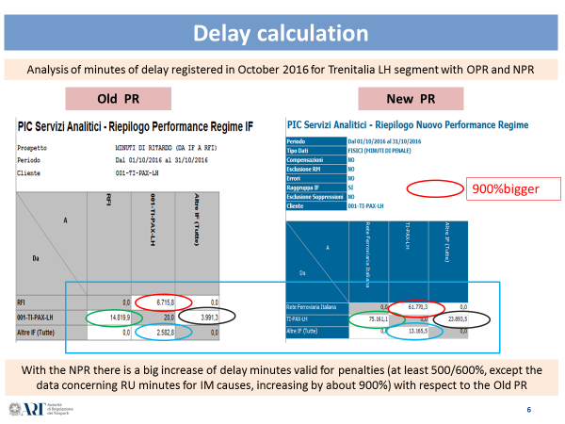
- With the NPR there is a considerable increase in the minutes of delay caused by the IM, as well as an increase in the penalty flows:
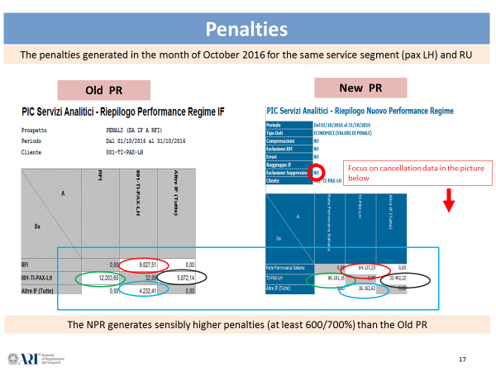
- With the NPR penalties for cancellation have a significant impact on freight services only:
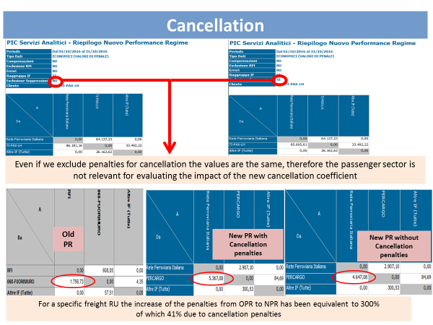
- The reason of this increase in terms of penalties and minutes of delay is related to the removal of delay thresholds and the registration of delays at intermediate stations along the route. Hence, it is interesting to compare the increase of delays with the increase of the correlated penalties.
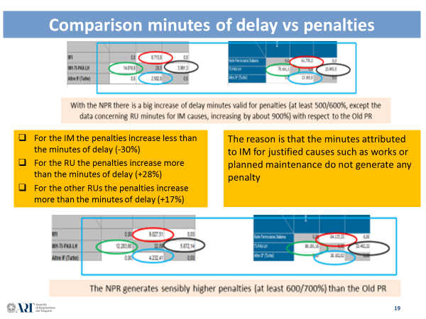

- It is worth highlighting that the IM penalties increase less than the minutes of delay, because some of those minutes are justified and not accountable for penalties. This is the case of the minutes attributed to planned works or minutes related to delays generated by trains coming from neighbouring countries.
- Here below 2 examples are shown.
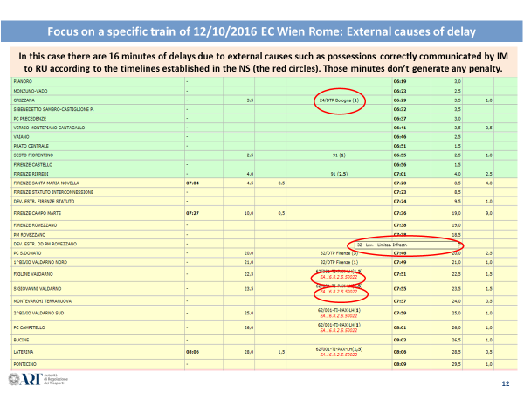
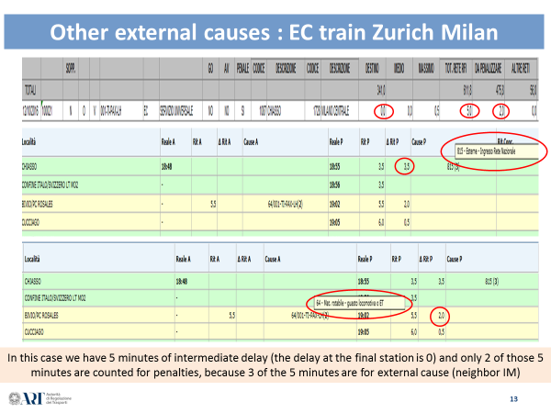
- The delay attribution and delay validation are processes described in an official procedure published by the IM (Cp269 of RFI).
- For the delay validation, the above-mentioned document describes all the causes of delay broken down by area of origin:
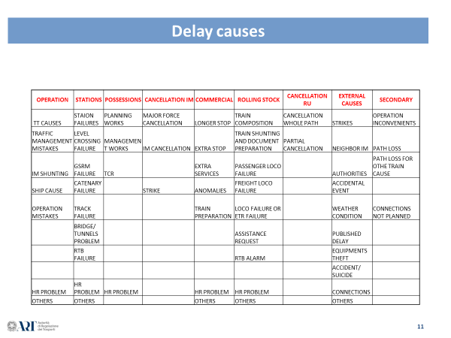
- Those causes are attributed by the IM. The RUs can accept or refuse the delay attribution by using the dedicated IM IT management tool (PIC web).
- Should the RU not agree, if it does not lodge a complaint within the following 20 days, the delay attribution is considered as accepted and cannot be modified any longer.
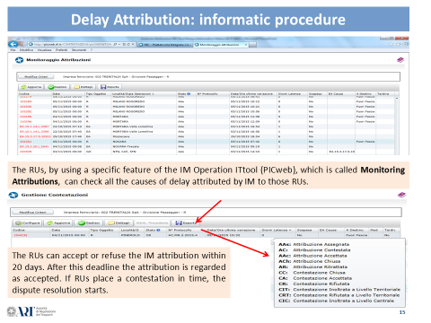
- In case of disagreement on the delay attribution, a dispute resolution procedure will most likely be initiated. Usually the majority of these procedures are settled at regional level, without the need to involve higher levels of IM’s and RU’s managerial hierarchy or the regulatory body as a last resort.
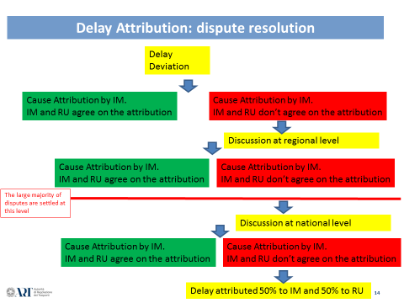

- The NPR has proved to be an important instrument in the past years to increase the performance of the users of the Italian railway network. The historical series concerning the economic flows from 2012 to 2016 are shown in the following pictures.
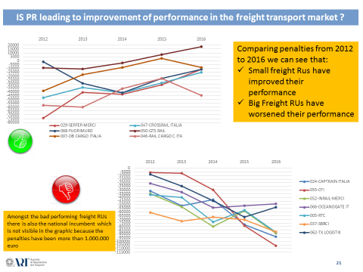
- There was an improvement in the performance of small freight RUs and a decline in the performance of large-sized freight RUs , especially in the case of the freight incumbent RU (MerciItalia Rail).
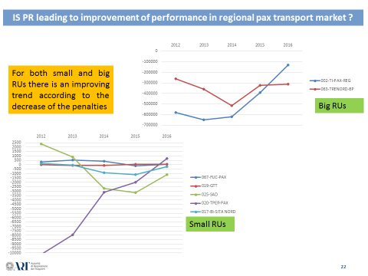
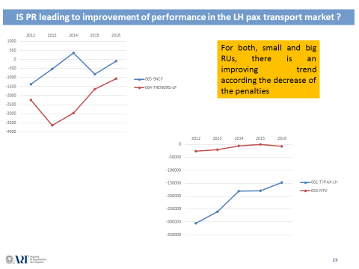
- There was an improvement for both LH and Regional RUs.

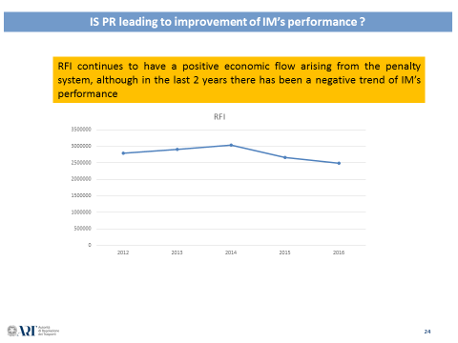

- There was a modest decrease of the IM performance that nevertheless has still led to a positive economic flow.
- Finally, it is important to mention the bonus procedure, so as to understand the calculation system that apportions the 80% of the IM penalty-related income amongst the best operating RUs with a separation of the economic flows for freight and passenger RUs.
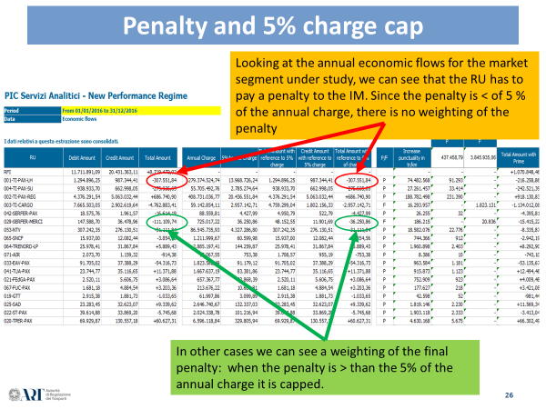

- As a first outcome, it can be observed that, especially for small-sized RUs, the threshold based on 5% of the annual charge for the total PR penalty appears to be a quite significant one. Having chosen a large-sized RU with a relevant annual charge in the selected case study, no penalty reduction (red circles) is observed.
Client | TOTALE 2016 | TOTALE 2015
 | TRENI*KM PUNT. | TRENI*KM PUNT. | VAR% | C_{Base} | Punt. IF | V/M | C_{Correttivo} | C_{P} | TRENI*KM PUNT.  INCR.
001-TI-PAX-LH | 55.172.272,260 | 52.790.474,262 | 4,51 | 1,05 | 97,00 | V | 0,30 | 1,35 | 74.482.567,551
004-TI-PAX-SU | 22.717.881,163 | 20.762.228,817 | 9,42 | 1,05 | 94,70 | V | 0,15 | 1,20 | 27.261.457,396
002-TI-PAX-REG | 145.217.306,204 | 142.033.622,694 | 2,24 | 1,05 | 96,70 | V | 0,25 | 1,30 | 188.782.498,065
003-TI-CARGO | 16.293.957,053 | 16.498.907,557 | -1,24 | 1,00 | 76,60 | M | 0,00 | 1,00 | 16.293.957,053
900-TI-DT | 0,000 | 3.906,314 | 0,00 | 1,00 | 0,00 | V | 0,00 | 1,00 | 0,000
042-SERFER-PAX | 26.254,576 | 27.308,359 | -3,86 | 1,00 | 91,40 | V | 0,00 | 1,00 | 26.254,576
029-SERFER-MERCI | 148.972,314 | 294.733,161 | -49,46 | 1,00 | 92,20 | M | 0,25 | 1,25 | 186.215,393
053-NTV | 13.272.911,784 | 11.944.678,660 | 11,12 | 1,10 | 97,60 | V | 0,30 | 1,40 | 18.582.076,498
065-SNCF | 531.690,135 | 533.762,713 | -0,39 | 1,00 | 99,30 | V | 0,40 | 1,40 | 744.366,189
064-TRENORD-LP | 1.400.641,777 | 1.377.753,895 | 1,66 | 1,05 | 98,30 | V | 0,35 | 1,40 | 1.960.898,488
071-AIR | 7.987,076 | 0,000 | 0,00 | 1,00 | 92,50 | V | 0,05 | 1,05 | 8.386,430
033-EAV-PAX | 770.867,201 | 700.547,299 | 10,04 | 1,10 | 94,60 | V | 0,15 | 1,25 | 963.584,001
041-TUA-PAX | 796.411,356 | 769.204,428 | 3,54 | 1,05 | 93,60 | V | 0,10 | 1,15 | 915.873,059
021-FEdGA-PAX | 456.308,544 | 292.784,192 | 55,85 | 1,30 | 98,60 | V | 0,35 | 1,65 | 752.909,098
067-FUC-PAX | 126.876,717 | 127.075,770 | -0,16 | 1,00 | 99,20 | V | 0,40 | 1,40 | 177.627,404
019-GTT | 30.427,110 | 34.541,529 | -11,91 | 1,00 | 99,30 | V | 0,40 | 1,40 | 42.597,954

- In order to determine which part of the 80% IM bonus has to be apportioned to the RU considered in the case study, it is necessary to measure the punctuality deviation from 2016 to 2015. The first row shows a positive variation of 4.51%. This value is useful to find the correct value for the Cbase coefficient. Taking into account only the RU causes of delay, the result is 97% and this corresponds to a value of Ccorrective coefficient equal to 0.30 according to table 5b published in Annex C, Chapter 6 of the Italian NS (edition December 2016).

- Cp can now be calculated:
CP=CB+CCORR
CB: increase of the performance concerning train/km punctuality according to RU standard
CCORR: punctuality function according to RU standard in the year (X) (different value for passenger and freight RUs)

- If Cp is multiplied by the value of train-km punctuality for 2016, an increase of 74.482.567 (last column of the table shown in this page) is observed.

 |  |  |  |  |  | Bonus to redistribute | Bonus to redistribute
 |  |  |  |  |  | Pax | Freight
RU |  | Total Amount with reference to 5% of charge |  | P/F | Increase punctuality in tr/km | 437.458,79 | 3.845.935,06 | Total Amount with Bonus
RFI |  | - |  |  | - | - | - | +1.070.848,46
001-TI-PAX-LH |  | -307.551,84 |  | P | 74.482.568 | 91.293 | - | -216.258,86
004-TI-PAX-SU |  | -275.935,65 |  | P | 27.261.457 | 33.414 | - | -242.521,39
002-TI-PAX-REG |  | +686.740,90 |  | P | 188.782.498 | 231.390 | - | +918.130,83
003-TI-CARGO |  | -2.957.142,71 |  | F | 16.293.957 | - | 1.823.131 | -1.134.012,08
042-SERFER-PAX |  | -4.427,99 |  | P | 26.255 | 32 | - | -4.395,81
029-SERFER-MERCI |  | -36.250,86 |  | F | 186.215 | - | 20.836 | -15.415,22
053-NTV |  | -31.111,84 |  | P | 18.582.076 | 22.776 | - | -8.335,87
065-SNCF |  | -3.854,56 |  | P | 744.366 | 912 | - | -2.942,19
064-TRENORD-LP |  | +5.889,43 |  | P | 1.960.898 | 2.403 | - | +8.292,90
071-AIR |  | -753,38 |  | P | 8.386 | 10 | - | -743,10
033-EAV-PAX |  | -54.316,73 |  | P | 963.584 | 1.181 | - | -53.135,67
041-TUA-PAX |  | +11.371,88 |  | P | 915.873 | 1.123 | - | +12.494,46
021-FEdGA-PAX |  | +3.086,64 |  | P | 752.909 | 923 | - | +4.009,48
067-FUC-PAX |  | +3.203,36 |  | P | 177.627 | 218 | - | +3.421,08
019-GTT |  | -1.033,65 |  | P | 42.598 | 52 | - | -981,44
025-SAD |  | +9.339,62 |  | P | 1.819.146 | 2.230 | - | +11.569,34
022-ST-PAX |  | -5.745,68 |  | P | 1.903.118 | 2.333 | - | -3.413,04
020-TPER-PAX |  | +60.627,31 |  | P | 4.630.168 | 5.675 | - | +66.302,49
061-TFT-PAX |  | +148,70 |  | P | 1.355 | 2 | - | +150,36
063-TRENORD-BP |  | -646.382,14 |  | P | 33.075.095 | 40.540 | - | -605.842,13
069-TTE |  | +5.644,06 |  | P | 620.510 | 761 | - | +6.404,62
017-BI-SITA NORD |  | -488,66 |  | P | 4.484 | 5 | - | -483,16
024-CAPTRAIN ITALIA |  | -355.350,17 |  | F | 3.045.386 | - | 340.748 | -14.601,96
055-CFI |  | -232.407,31 |  | F | 1.754.171 | - | 196.274 | -36.133,10
047-CROSSRAIL ITALIA |  | -56.857,56 |  | F | 450.324 | - | 50.387 | -6.470,87

- Before calculating the bonus for the RU considered in this case study, it is necessary to define the bonuses for both the passenger and freight market. This is done by summing up all the penalties for passenger RUs (second column) and freight RUs and multiplying them by 80%. The results are 437.458,79 for passenger and 3.845.935,06 for freight.
- The last step is to divide the increase in punctuality of each RU by the total penalties for their own sector and multiply them by the total bonus of the same sector.
- In terms of figures:
74.482.567/∑increase of punctuality passenger RUs*437.458,79= 91.293
- If there is a bonus for the RU, then there is a decrease of the penalty value (last column):
307.551,84-91.293=216.258,86

- Concluding remarks: The Italian Regulatory Body (ART) has driven the change of the NPR, establishing the main principles for the new scheme, in order to encourage players to ensure greater reliability in the provision of their services.
- Furthermore, ART has decided to impose a separate apportionment of bonuses for passenger RUs and for freight RUs. In this way, as shown in the table, the bonus to be re-distributed to freight RUs has a higher value. Accordingly, the single bonus per freight RU is higher: this is very important because freight penalty values are considered to be more relevant than those for the passenger sector, as they allow for a better focus on the specific areas of improvement of the freight sector.
- The main role of the Regulatory body from now on will be to monitor the outcomes of the performance regime and the correct attribution of the delay by the IM, also through the IM IT tools dedicated to the monitoring of NPR, in order to avoid discrepancies between the service levels and quality of train operations registered throughout the railway network and the penalties/bonuses generated by the NPR. This also with a view to impose to the IM any further revision or fine-tuning of the performance regime which is deemed necessary.
- In the future, a recalibration of the NPR may become useful to make it more challenging for the IM and gradually avoiding any kind of justification of delay caused by the IM. Moreover, it would be advisable to include a detailed analysis of freight penalties to evaluate a revision of the freight NPR.
- Last but not least, it would be worth reviewing the concept of penalty, with a view to calculate the amount of penalties on the basis of the real loss of revenue caused to other stakeholders (other RUs or IM).

In Slovenia Art. 43 of the respective decree determines the “basic principle “of the performance scheme, but the methodology is published in network statements.
In Romania the list is published in both, in the NS and in the contract access agreement.
In Lithuania the allocation authority is at the same time the national safety authority.
RNE (2013): European Performance Regime, http://www.rne.eu/tm-tpm/european-performance-regime/, downloaded 17.10.2017.
Abbreviations: D stands for the total sum of delay minutes in Euro and t is the delayed time in minutes.
According to the working timetable – which is what the industry is trying to deliver on any given day - and not the ‘published’ timetable.
Each monitoring point has a weighting, known as Monitoring Point Weightings (MPWs). The weightings reflect the proportion of passenger journeys that are completed at the monitoring point or one of the stations preceding it which has not been designated a monitoring point. The sum of all weightings in a service group (and peak type) must sum to 1.
This is a simplification for this example. The end point of a service is always a monitoring point – so there will typically be at least two monitoring points for any given service (given the start of a service is the end of the same service when it runs in the other direction)
TRUST = Train Running Under System TOPS, where TOPS stands for Total Operations Processing System. TRUST is the Network Rail delay attribution system.

